**ECEN 248 - Lab Report**

**Laboratory Exercise #2**

**Logic Minimization with Karnaugh Maps**

**ECEN-248-509**

**Joaquin Salas**

**731000141**

**09-20-2022**

**Sri Hari Pada Chandanam Kodi**

**Objectives:**

This lab assignment aims to introduce students to applying digital circuits in a real-world scenario and utilizing Karnaugh-Maps for logic minimization. Using a breadboard and logic gates, it is possible to create a simple circuit that will calculate profits on a small farm for several given combinations, and conditions. Also at the end, the output will be signaled into a seven-segment display to show the profit number.

**Design:**

In this design, create a simple digital circuit to compute the total profits made by an animal farm. The following is a set of guidelines for setting up the farm:

1. He can raise cows, sheep, hogs, and chickens on his farm but can’t raise them all at the same time.

2. The farm does not have enough space to raise more than 2 different types of animals.

3. Each type of animal earns a certain level of profit for the farm, Cows earn a profit of 4 units, sheep earn a profit of 2 units, hogs earn 3 units and chickens earn a profit of 1 unit.

There are a few special cases when some animals are raised together:

1. If he plans to raise hogs and chickens together, his profits go down by 1 unit.

2. Similarly, if he raises cows and chickens his profits go down by 1 unit. Additionally, cows tend to kill some chickens on the farm. This also reduces his profits by 1 unit.

3. Cows and sheep do very well if raised together. Due to the huge demand for these, the profit goes up by 1 unit.

The digital circuit will take these 4 types of animals, I (Chicken), S (Sheep), C (Cow), H (Hog), and the output bits are P2, P1, and P0 such that P2 is the more significant bit. Since there are 4 input bits, the truth table will contain 24 = 16 rows. Outputs not possible because of limitations of the farm will be “X” for “don’t cares.” After simplifying the logic expression for each output bit, draw a gate-level schematic of the logic design.

**Experiment Part 1:**

Consult datasheets of each component for pin-outs and electrical/timing characteristics of the circuits. In the first part, the circuit will test the calculator with 3 different LEDs turning on according to the truth table.

1. Place all required chips on the breadboard
2. Connect VCC and GND for the chips
3. Define the input signals listed above and implement the output P0 according to the gate level schematic and connect to LED.
4. Repeat step d to implement P1 and debug it.
5. Repeat step d to implement P2 and debug it.
6. Test several different input combinations and test your logic design.

**Experiment Part 2:**

In this part of the lab we will display the output of the profit calculator on a seven-segment display. Do this by:

1. Remove the LEDs from the circuit created in part 1 and connect the output bits from the profit calculator to the inputs for the seven-segment display decoder. The profit calculator has 3 outputs, while the decoder requires 4, to make this work, connect pin D to ground and pins C/B/A to P2/P1/P0 respectively.
2. Connect the decoder to the seven-segment display referring to Figure 7 on the lab report and, connect pin 3 and 470Ω resistor to protect the display from being destroyed.

**Results:**

The results of my experiment showed that any combinations of input values on the truth table lit up the correct corresponding output values. After testing several different inputs and checking with the output truth table, all combinations were correct and they were observed by my TA, Sri. The results of this experiment when connected to the seven-segment display showed the amount of profit that John would create with any possible combination of animals. For example, when cow and sheep were used as the input, the number “seven” would be displayed.

**Conclusion:**

This lab was great for understanding the logic behind logic minimization using Karnaugh-maps. If not for the Karnaugh-maps, the circuit would have been much more complicated and would be much harder to organize onto the breadboard. This lab also taught me more about working on breadboards and trying to keep the circuit neat by color coordination and organizing wires.

**Post-lab Deliverables:**  
 1. Make a table with 16 rows showing the digital inputs and outputs of your circuit observed during lab. For input combinations not allowed by the aforementioned guidelines, provide the actual output values observed rather than ‘X’.

|  |  |  |  |  |  |  |  |  |
| --- | --- | --- | --- | --- | --- | --- | --- | --- |
|  | **S** | **I** | **H** | **C** | **P2** | **P1** | **P0** |  |
|  | 0 | 0 | 0 | 0 | 0 | 0 | 0 | **0** |
| **C** | 0 | 0 | 0 | 1 | 1 | 0 | 0 | **4** |
| **H** | 0 | 0 | 1 | 0 | 0 | 1 | 1 | **3** |
| **H/C** | 0 | 0 | 1 | 1 | 1 | 1 | 1 | **7** |
| **I** | 0 | 1 | 0 | 0 | 0 | 1 | 1 | **1** |
| **I/C** | 0 | 1 | 0 | 1 | 0 | 1 | 1 | **3** |
| **I/H** | 0 | 1 | 1 | 0 | 0 | 1 | 1 | **3** |
| **I/H/C (X)** | 0 | 1 | 1 | 1 | 1 | 1 | 1 | **7** |
| **S** | 1 | 0 | 0 | 0 | 0 | 0 | 0 | **2** |
| **S/C** | 1 | 0 | 0 | 1 | 1 | 1 | 1 | **7** |
| **S/H** | 1 | 0 | 1 | 0 | 1 | 1 | 1 | **5** |
| **S/H/C (X)** | 1 | 0 | 1 | 1 | 1 | 1 | 1 | **7** |
| **S/I** | 1 | 1 | 0 | 0 | 0 | 1 | 1 | **3** |
| **S/I/C (X)** | 1 | 1 | 0 | 1 | 1 | 1 | 1 | **7** |
| **S/H/C (X)** | 1 | 1 | 1 | 0 | 1 | 1 | 1 | **7** |
| **S/I/H/C (X)** | 1 | 1 | 1 | 1 | 1 | 1 | 1 | **7** |

2. What values does your circuit output for the “don’t care” inputs and why?

As shown on the truth table, whenever a “don’t care” set of values is input to the circuit, the display shows a “7”, I believe this is because all P2, P1, and P0 have 1’s for all the results. All 5 “don’t care” inputs were tested and observed by my TA, Sri.

3. Take a picture of your complete circuit with the seven-segment display. Try your best to introduce your product to John and teach him how to use it.

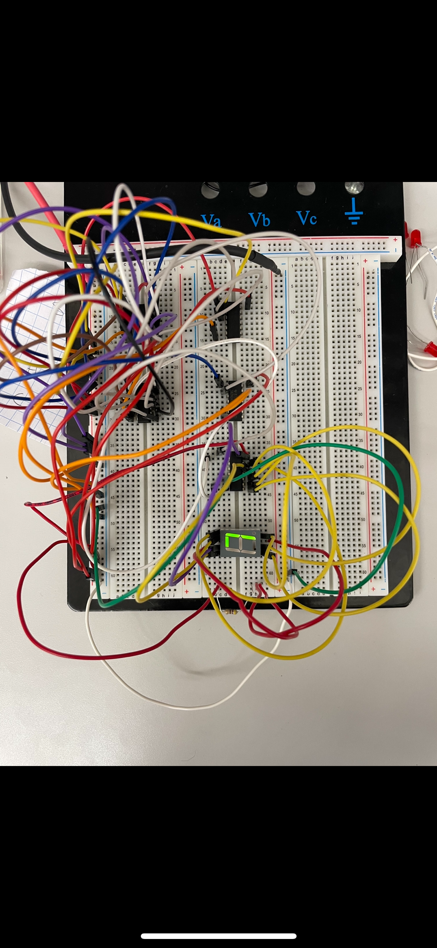

Howdy John, this simple device is called a profit calculator and it has been custom-made with your little farm in mind! This calculator allows you to input any 2 animals of your preference and will give you the amount of profit you will earn with all the conditions on your farm. To use it there are 4 wires on the side of the breadboard, they are set to “off” which means they are on the ground not being used. To test any animal or animals, you will do this by moving the colored wire corresponding to that animal onto the “on” or positive side. In the picture attached above, there is a combination from which you will profit the most. The combination here is cows and sheep, it will get you 7 units of profit. The wires correspond as shown:

* Orange : Chicken
* Purple : Cow
* Red : Hog
* Blue : Sheep